**IEEE Student Chapter, Thapar University**

**IEEE Event**:  **How to Crack Civil Service Exams in First Attempt**

**Date: May 1, 2017 Venue: C- Hall**

**Time: 5:05 pm to 7:30 p.m.**

**No. of Students Attended: Sixty Two**

**Facebook Link: https://www.facebook.com/ieee.thapar/**

**Speaker: Mr. Lachman Singh (Delhi based Academician)**

**Brief Bio:** Mr. Lachman Singh Maluka is Director at MALUKA’S IAS, Delhi. He has done his Masters from School of Governance at MIT, Pune. He has five years of experience in teaching general studies. Recently, He has started his own civil services institute in Jan 2016. And in a very short span of time he has produced good results. In the first batch of twenty six students, twenty two students cleared Prelims. Nine of them cleared Mains. He has recently opened one of the branches at Patiala and is soon planning to open more institutes in Punjab. He has done agreement with MISSION IAS in Amravati (Maharashtra) for providing free education to poor students. In every institute, he would provide free coaching to 20 poor and hard-working students. He has done agreement with Suryoday Institute (Indore, Madhya Pradesh) to provide free online classes from June-July 2017 for IAS/PCS in 250 institutes of higher education allocated to Suryoday Institute by Madhya Pradesh Government.

|  |  |
| --- | --- |
| **Poster Circulated** |  |

**Report**

This event was organized on demand of third year students. Approximately fifty Students of all branches and batches attended the event enthusiastically. Students spared precious time from their busy schedule in last week of the semester. The session started with a motivational speech by Mr. Lachman Singh where he highlighted some social issues existing in the nation. In the latter session, the speaker discussed the strategies on how to crack and prepare for civil services exam. Mr. Saurav Sharma described the eligibility criteria, the right age to start preparing for civil services exam and kind of zeal and determination needed to be a bureaucrat. Mr. Lachman Singh and Mr. Saurav Sharma answered students’ queries regarding civil services preparation in last half an hour of the session. The students were really keen to know about the preparation strategies that the one hour session stretched to two and a half hour.

**Photographs**: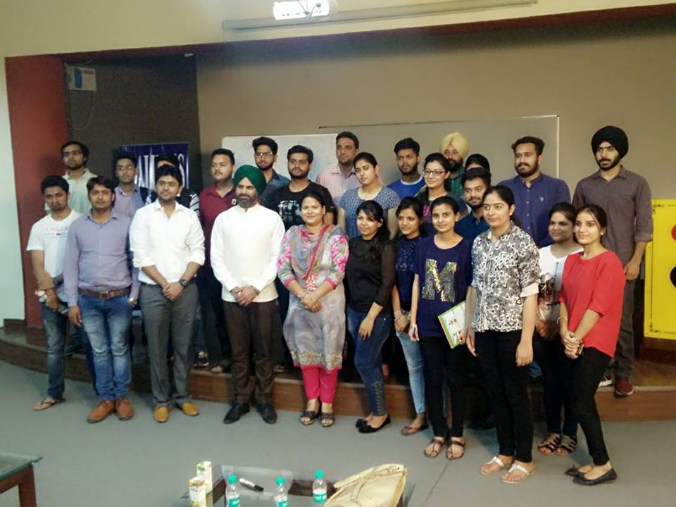

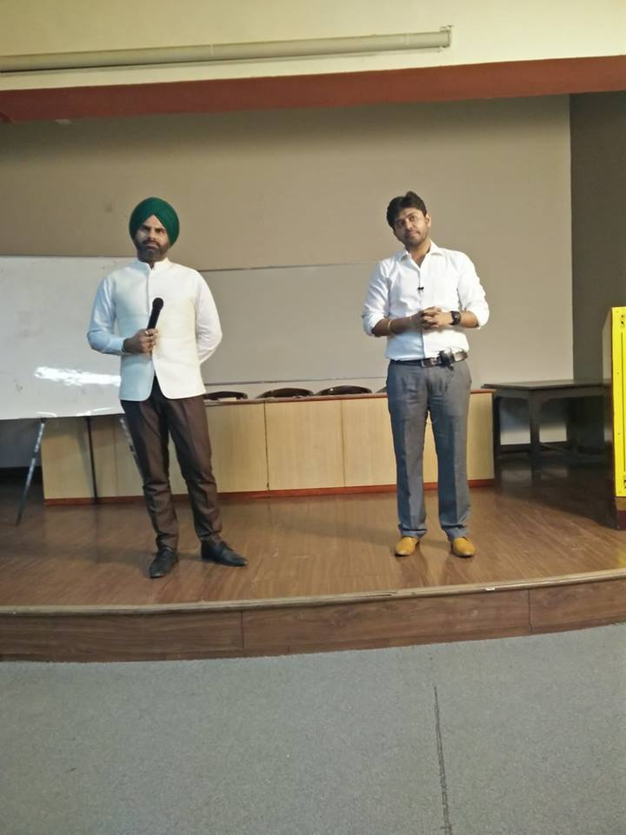

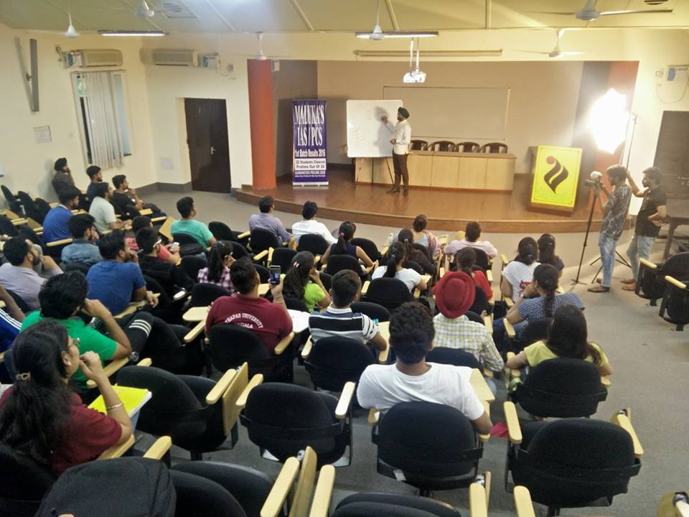

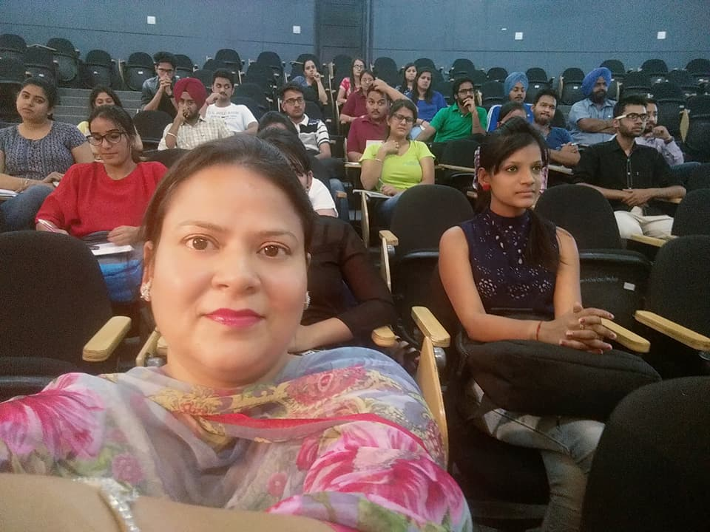

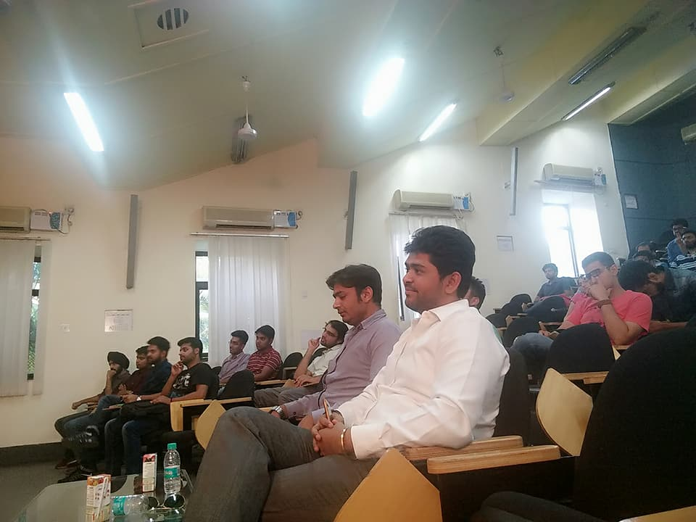

|  |  |  |
| --- | --- | --- |
| **IEEE Event** | **Attendance May 1,2017** | |
| **Roll No** | **Name** | **Class** |
| 801631008 | Gurveer Singh | ME SE |
| 801631007 | Gursimran Kaur | ME SE |
| 801631005 | Damini Arora | ME SE |
| 801631004 | Ashamdeep Kaur | ME CS |
| 801631003 | Ankita Verma | ME CS |
| 801631002 | Amanpreet Kaur | ME IS |
| 101411004 | Akshay | BE CE 3rd |
| 101453008 | Aayush Garg | BE CAG 3rd |
| 801631001 | Aanchal | BE CAg3rd |
| 801631016 | Pavleen Kaur | ME SE |
| 101411001 | Aarushi | BE III |
| 101411002 | Abhishek Singla | BE III |
| 101411003 | Adarsh Mour | BE III |
| 101411005 | Anmol | BE III |
| 101411006 | Anshul | BE III |
| 101411009 | Ayush | BE III |
| 101411013 | Gaurav | BE III |
| 101411015 | Gursimran Singh | BE III |
| 101411016 | Himanshu Hans | BE III |
| 101411017 | Ishaan | BE III |
| 101411019 | Manas | BE III |
| 801631017 | Saryu Verma | ME I |
| 801631018 | Shefali Singh | ME I |
| 801631019 | Surbhi Singla | ME I |
| 801631020 | Swetaleena Panda | ME I |
| 801631022 | Vikram Kumar | ME I |
| 801631023 | Vivek Singh Bhandari | ME I |
| 101411010 | Brijendra | BE III |
| 101591002 | Kamal | BE Final |
| 101591001 | Anchal | BE Final |
| 101411020 | Manav Bedi | BE Mech |
| 101411018 | Kabir | BE Mech |
| 101411014 | Gurpreet Singh | BE Mech |
| 101411012 | Dhruv | BE Mech |
| 101411011 | Deepansh | BE Mech |
| 101411008 | Avi Kalra | BE CE 3rd |
| 101403209 | Yatin Dang | BE CE 3rd |
| 101410054 | Sumit Dahiya | BE CE 3rd |
| 801631012 | Singh Monty | ME I |
| 101590006 | Shivam Thaman | BE CE 3rd |
| 801631015 | Neha Sharma | ME I |
| 801631014 | Nancy Sharma | ME I |
| 801631013 | Naincy Katyal | ME I |
| 101410037 | Mokshit | BE |
| 801631011 | Manmeet Kaur | ME I |
| 101411022 | Manjot Singh | ME I |
| 801631010 | Kirti Sharma | ME I |
| 101410029 | Jatin Singhal | ME I |
| 801631009 | Jasteen Kaur | ME I |
| 801631008 | Gurveer Singh | ME I |
| 801631007 | Gursimran Kaur | ME I |
| 801631005 | Damini Arora | ME I |
| 801631004 | Ashamdeep Kaur | ME I |
| 801631003 | Ankita Verma | ME I |
| 801631002 | Amanpreet Kaur | ME I |
| 101411004 | Akshay | BE CE 3rd |
| 101453008 | Aayush Garg | BE CE 3rd |
| 101403011 | Abhinav | BE CE 3rd |
| 101412035 | Sehaj | BE CE 3rd |
| 101403026 | Akshay Bhansali | BE CE 3rd |
| 101303024 | Ankita Singh | BE Final |
| 101203115 | Vishal | BE Final |
| 101411021 | Manish | BE |
| 101412037 | Shubham | BE |
| 101590003 | Arun Kumar | BE |
| 101590005 | Sahil Chauhan | BE |
| 801533016 | Yashika Garg | ME IS Second |
| 801533014 | Shivani Pahuja | ME IS Second |
| 801533013 | Shifali Sharma | ME IS Second |
| 801533012 | Mehak | ME IS Second |
| 801533011 | Mandeep Kaur | ME IS Second |
| 801533010 | Jobanjeet Kaur | ME IS Second |
| 801533009 | Harpreet Kaur | ME IS Second |
| 801533015 | Vidhi | ME IS Second |
| 801532011 | Parampreet | ME SE Second |
| 801531005 | Neha Mittal | ME CS Second |